USER GUIDE

Installing The Java Plug In
- Internet Explorer Users
- Netscape Communicator Users

Login

Main Windows
- Dealing Rates
- Currency
- Account Information
- Trader's Orders
- Open Positions
- Summary

Orders
- Market Orders
- Entry Orders
- Stop-Loss Orders
- Limit Orders
- Close an Open Position

Additional Features
- Trading History
- Reports
- Menu Commands

INSTALLING THE JAVA PLUG IN

The Internet Currency Trading System requires the installation of the Java Runtime Environment 1.2. Follow the instructions below for installing this free program from Sun Microsystems. BizFOREX™ recommends downloading this program with Microsoft Internet Explorer.

Internet Explorer Users:
1. | Click on the "DEMO TRADING" button that appears on the Log-IN page of this web site.
2. | Click on the "LOGIN" button.
3. | A screen will load and a pop up window titled "Security Warning" will appear. Click on "Yes".
4. | A new pop up window will appear, click on "Install".
5. | The program download will take approximately 25 minutes with a 56K modem.  DSL, T1, or other faster connections will take less than 1 minute
6. | A license agreement will appear, click on "Accept" to proceed.
7. | On the following pop up window, click on "Next".
8. | For installation to be completed, the computer needs to be re-started. The new pop up window will have a "Finish" button. Clicking on this button will re-start the computer.
9. | The computer is ready to Log In.


Netscape Communicator Users:
1. | Click on the "DEMO TRADING" button that appears on the Log-IN page of this web site.
2. | Click on the "LOGIN" arrow.
3. | A pop up window titled "Plug-in Not Loaded" will appear. Click on "Get Plug-in"
4. | Scroll down until "Download the Java runtime environment" is highlighted.
5. | U.S. residents should click on the radial button next to "one large bundle" under "U.S. English version of Java runtime environment".  Non-U.S. residents should click on the radial button next to "one large bundle" under "Internationalized version of Java runtime environment".
6. | Click "Continue".
7. | To proceed, you must click "Accept" on the new page that appears.
8. | When another page appears, click on the "HTTP download" button that is located under "Download from Java.sun.com". http://java.sun.com/downloads5 The program download will take approximately 25 minutes with a 56K modem.  DSL, T1, or other faster connections will take less than 1 minute
9. | When prompted for a location to store/save the file, select desktop. Click on "Save".
10. | Close down all open programs and files being used. On the desktop, find the program just downloaded and double click on it.
11. | To proceed click "Yes", when the user agreement appears. On the following pop up window, click "Next".
12. | The computer is ready to Log in.

LOG IN

Click on the "DEMO TRADING" button that appears on the Log-IN page of this web site. Click on the "LOGIN" button. The window below should appear.

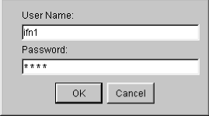

Enter the user name and password, exactly as displayed on the E-mail confirming the Demo Account registration.
Note: If this window does not pop up, the Java Plug-in is not installed on your system properly. Please review the Java Plug-In Installation Procedure.

MAIN WINDOW

There are six windows on the main page of the Internet Currency Trading System. The size of each window can be adjusted to your personal preference. To expand or truncate a window, left mouse click on one of the internal window borders. While pressing on the left mouse button, move the mouse back and forth. Let go of the left mouse button when the border is adjusted to your preferred specifications.

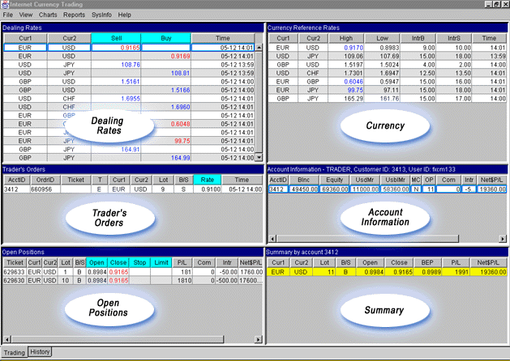

Dealing Rates
(Upper Left Hand Window)
This window displays the exchange rates at which you can deal. For each currency pair in each tradable currenyc, there are two rows. One row contains the price at which you can "Sell" and the other row indicates the price at which you can "Buy". "Sell" or "Buy" refers to the currency listed in the Column "Cur1". The opposite operation happens to the currency listed in column "Cur2" when a trade is executed. Each time an exchange rate is changed, the time of the change is indicated under the column "Time".
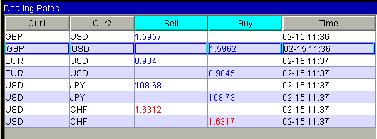
(Note: There are only four currency pairs pictured in the above diagram. There has since been added three additional pairs.)

Currency
(Upper Right Hand Window)
For each currency pair this window displays three pieces of information, "high", "low", and "IR". Under the "high" and "low" columns, the extreme high and low quotations are recorded over 24-hour period of time beginning at 5:00 PM Eastern Standard Time (US). The "IR" refers to the amount of funds in dollars per open lot that are added or subtracted from an account at 5:00 PM Eastern Standard Time when positions are rolled over. For each currency pair, this number is different. The number is changed two hours in advance of roll over in order to reflect the day's market conditions.

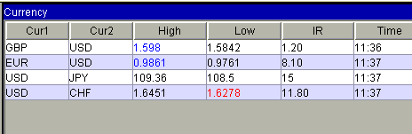

Account Information

(Middle Right Hand Window)
This window displays important account information, under the following columns "Equity", "UsdMr", "UsblMr", "OP", "OO", and "FltP/L".
"Equity" - The combined value of the account deposits and holdings, if open positions are immediately closed at market prices.
"UsdMr"(Used Margin) - The amount of equity required to maintain all open positions.
"UsblMr" (Usable Margin) - The amount of equity available to open new positions.
OP (Open Positions) - The number of lots currently held open by the account.
OO (Open Orders) - The number of lots currently waiting to be executed in the Trader's Orders window.
"Flt P/L" (Floating Profit/Loss) - The profit or loss that would result from the closing of all open positions.

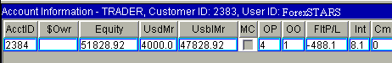

Trader's Orders
(Middle Left Hand Window)
Active entry orders appear in this window. Each order has unique ticket number and is located on a separate row. The currency pair, the operation (Buy or Sell), the number of lots, and activation level are displayed for every order. In addition, the time the order was entered is also displayed.

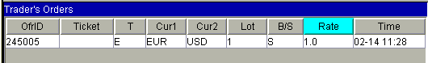

Open Positions

Lower Left Hand Window
All open positions are displayed in this window. Each position has unique ticket number and is located on a separate row. Below are explanations for several of the columns that appear in this window.
"Open" - The exchange rate at which the position was opened.
"Close" - The exchange rate at which the position can be immediately liquidated.
"Stop" - The exchange rate at which a stop-loss order will be triggered to close position. If there is no stop-loss order on a particular position, the box under this column will appear empty for that position. (Stop-loss orders do not show in the Trader's Orders window.)
"Limit" - The exchange rate at which a limit order will be triggered to liquidate the close position. If there is no limit order on a particular position, the box under this column will appear empty for that position. (Limit orders do not show in the Trader's Orders window.)
"Interest" - The payments deducted or added to the account equity as a result of holding the position.
"P/L" - The profit or loss in pips, if the position was liquidated at the current market price.
"$P/L" - The profit or loss in U.S. dollars, if the position was liquidated at the current market price.
"Time" - The time the position was opened.

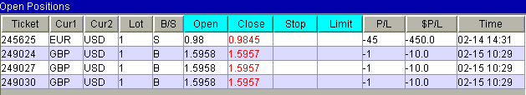

Summary

Lower Right Hand Window
This window enables you take an overall view of the positions held in an account. For each currency pair in which you have a position or positions, there is a separate row with data. Below are explanations for several of the columns that appear in this window.
"Lot" - The number of lots in that specific currency pair when all open positions are netted.
"Open" - The average exchange rate at which the lots were open.
"Close" - The exchange at which a lot can be closed.
"P/L" - The net floating profit or loss in pips for the lots held in a currency pair.
"$ P/L" - The net floating profit or loss in U.S. dollar for the lots held in a currency pair.
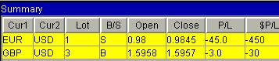

ORDERS

Market Orders

Initiate a Market order

In the Dealing Rates window, left mouse click on the exchange rate for the desired currency and operation (Buy or Sell). Or, right click on the appropriate rate and select Market order command from the pop-up menu. The "Take Order" window will appear and prompt the account Trader to input the desired number of lots.

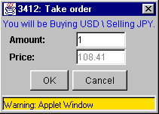

Enter desired amount measured in lots and click OK. A new order marked with the letter 'I' [Initiate] will appear on the Trader's Orders window. The dealer is now able to confirm transaction or reject transaction due to market movement. One of three scenarios may occur from after this:

- Dealer confirms order. The 'I' record will disappear and the new position record will be added to the Open Positions window. The account information will be updated.
Note: If Trader has already opened one or more positions in the same currency pair but in the opposite direction, the oldest of those positions will be closed instead of opening a new position record.
- Dealer rejects the order because of market movement. A new order marked with the letter 'R' [Reject] will appear on the Trader's Orders window instead of the 'I' order. This order will show the new market price. Trader is now able to accept the Dealer's new market price by right clicking on the specific order information and selecting Place order command from the pop-up menu. Trader may select not to accept the Dealer's new market price by right clicking on the specific order information and selecting Remove order command from the pop-up menu.

Trader wants to take the order back prior to a response from Dealer. Trader is able to cancel the order by right clicking on the specific order information and selecting Remove order command from the pop-up menu.

Entry Orders

Initiate Entry order:

In the Dealing Rates window, right mouse click on the exchange rate of the desired currency pair and operation (buy or sell). Then select the Entry order command from the pop-up menu. The "Take Order" window will appear and prompt the account Trader to input the desired number of lots and the desired price at which the account Trader wants to enter the market.

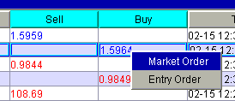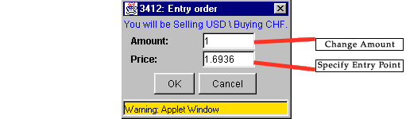

Input the desired amount measured in lots and adjust the price. When done, click OK. A new order marked with the letter 'E' [Entry] will appear on the Trader's Orders window. Dealer will execute the order when the market exchange rate touches or breaks through the specified price.

Change Price

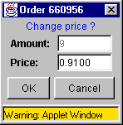

In the Trader's Orders window, left mouse click on the exchange rate under the "Rate" column for the appropriate position. Or, right click on the information for the appropriate position and select Change Price command from pop up menu. A "Entry Order" window will appear and prompt the account Trader to enter a rate. Adjust the rate and click OK. The new exchange rate at which the Entry order will be triggered will then appear in the box under the "Rate" column for the appropriate position.

Remove Entry Order
In the Trader's Orders window, right mouse click on the information for the appropriate position and select Remove Order command from pop up menu. The order will disappear.

Stop-Loss Orders

Place a Stop-Loss order

In the Open Positions or Trader's Orders window, left mouse click in the box in the "Stop" column right for the appropriate position. Or, right mouse click on the information for the appropriate position and select Place Stop command from the pop-up menu. A "Stop" window will appear and prompt the account Trader to enter a rate. Enter the Stop-Loss rate and click OK. The exchange rate at which the Stop-Loss order will be triggered will then appear in the box under the "Stop" column for the appropriate position.
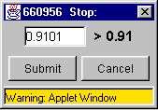

Change Price on Stops-Loss Order
In the Open Positions or Trader's Orders window, left mouse click on the exchange rate under the "Stop" column for the appropriate position. Or, right click on the information for the appropriate position and select Change Stop command from pop up menu. A "Stop" window will appear and prompt the account Trader to enter a rate. Enter the Stop-Loss rate and click OK. The new exchange rate at which the Stop-Loss order will be triggered will then appear in the box under the "Stop" column for the appropriate position.

Remove Stop-Loss Order
In the Open Positions or Trader's Orders window, right mouse click on the information for the appropriate position and select Remove Stop command from pop up menu. The exchange rate under "Stop" column for that position will disappear.

Limit Orders

Place a Limit Order

In the Open Positions or Trader's Order window, left mouse click in the box in the "Limit" column right for the appropriate position. Or, right mouse click on the information for the appropriate position and select Place Limit command from the pop-up menu. Enter the Limit rate and click OK. The exchange rate at which the Limit order will be executed will then appear in the box under the "Stop" column for the appropriate position.
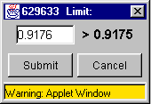

Change Price on Limit Order
In the Open Positions or Trader's Order window, left mouse click on the exchange rate under the "Limit" column for the appropriate position. Or, right click on the information for the appropriate position and select Change Limit command from pop up menu. A "Limit" window will appear and prompt the account Trader to enter a rate. Enter the Limit rate and click OK. The new exchange rate at which the Stop-Loss order will be triggered will then appear in the box under the "Limit" column for the appropriate position.

Remove Stop-Loss Order
In the Open Positions or Trader's Orders window, right mouse click on the information for the appropriate position and select Remove Limit command from pop up menu. The exchange rate under "Limit" column for that position will disappear.

Close Open Positions

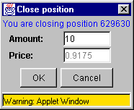

In the Open Positions window, right mouse click on the information for the appropriate position and select Close position command from the pop-up menu. The Close position window will appear indicating the number of lots for the particular position the Trader desires to close and Dealer's current market price at which the position will be closed.
Click OK. A new order marked with letter 'C' [Close] will appear on the Trader's Orders window. Dealer is now is able to confirm transaction or reject transaction due to market movement. One of three scenarios may occur from here:

- Dealer confirms the order. The 'C' record will disappear and the desired position will be closed. The account information will be updated.
- Dealer rejects the order because of market movement. The new order marked with the letter 'T' [Terminate] will appear on the Trader's Orders window instead of the 'C' order. This order will show the new market price. Trader is now able to send it back to Dealer (right click within the order record and select Place order command from the pop-up menu) or to cancel the transaction (right click within the order record and select Remove order command from the pop-up menu).
- Trader wants to take back his decision prior to response from Dealer. Trader is able to cancel the transaction by right clicking within the order record and selecting Remove order command from the pop-up menu.

ADDITIONAL FEATURES

Trading History
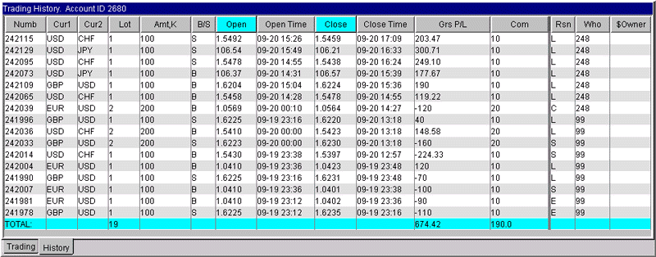
Click on the History tab handle, located at the bottom of the main page, to switch to the Trading History page. A detailed record of your last thirty completed trades in chronological order will be displayed. This page is extremely useful in tracking specific information on any recently closed trade.

Reports
To access this feature, click on "Reports", located on the top of the screen, and select the time period of interest. Clients can pull up a detailed report on their account status, on a daily, weekly, monthly or yearly basis. This report presents in a format ideal for printing key account information, such as records of floating positions and completed trades.

Menu Commands

The Menu has several headings including, "File", "View", "Reports", "Charts" and "Help".
"File" - After clicking on this heading, an Exit command can be accessed. This performs the same operation as closing the window.
"View" - After clicking on this heading, three options can be accessed. Each option if pressed will give the main window a slightly different visual style without altering the content.
"Reports" - See Above
"Charts" - This starts a charting applet. However, the applet only works on select computer platforms. We will be in the future providing charting software that can be used from all computer platforms.
"Help" - Please feel free to contact an BizFOREX™ staff member if there are any questions regarding using the Internet Currency Trading System.

